Day 1 (11-01-2021)

Select Clause with Where clause:

1. Display details of jobs where the minimum salary is greater than 10000.

Ans: select * from employees where salary > 10000;

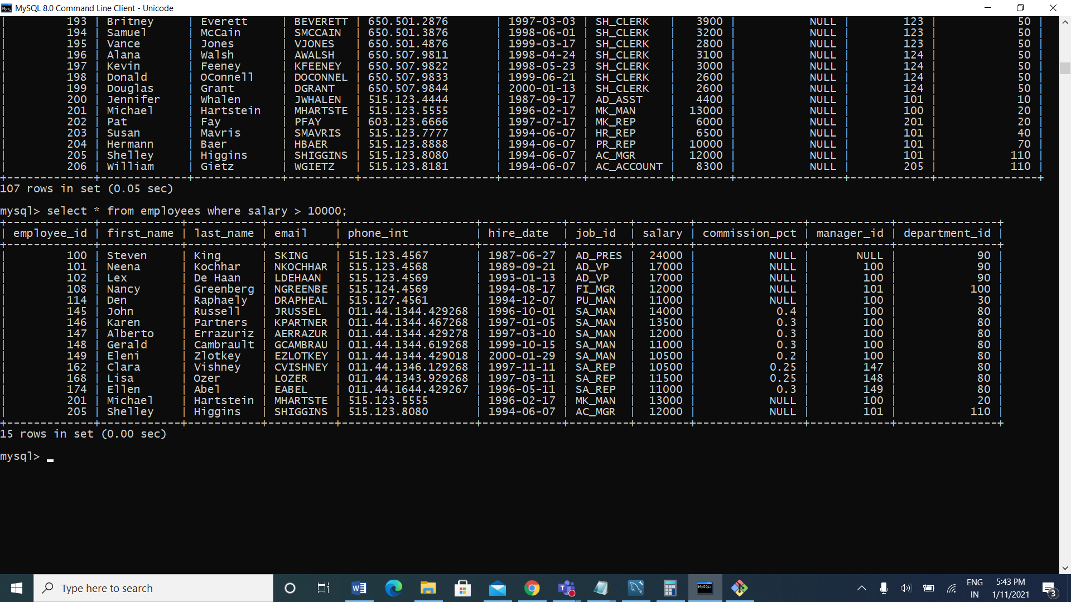

1. Display the first name and join date of the employees who joined between 2002 and 2005.

Ans: select job_title,department_name,last_name,start_date from job_history join jobs using (job_id)join departments using (department_id) join employees using (employee_id) where start_date between 2000 and 2005;

1. Display first name and join date of the employees who is either IT Programmer or Sales Man

Ans: SELECT FIRST_NAME, HIRE_DATE FROM EMPLOYEES WHERE JOB_ID IN ('IT_PROG', 'SA_MAN');



4. Display first name, salary, commission pct, and hire date for employees with salary less than 10000.

Ans: select first_name, salary, commission_pct,hire_date from employees where salary <10000.

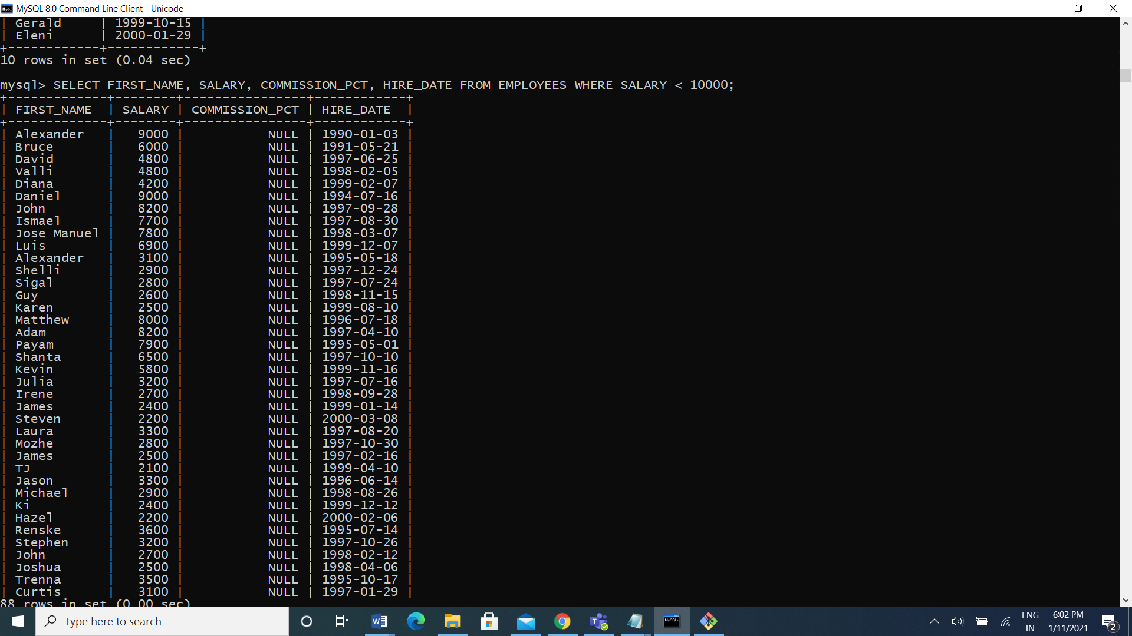

5. Display job Title, the difference between minimum and maximum salaries for jobs with max salary in the range 10000 to 20000.

Ans: select job_title, max_salary-min_salary difference from jobs where max_salary between 10000 and 20000;

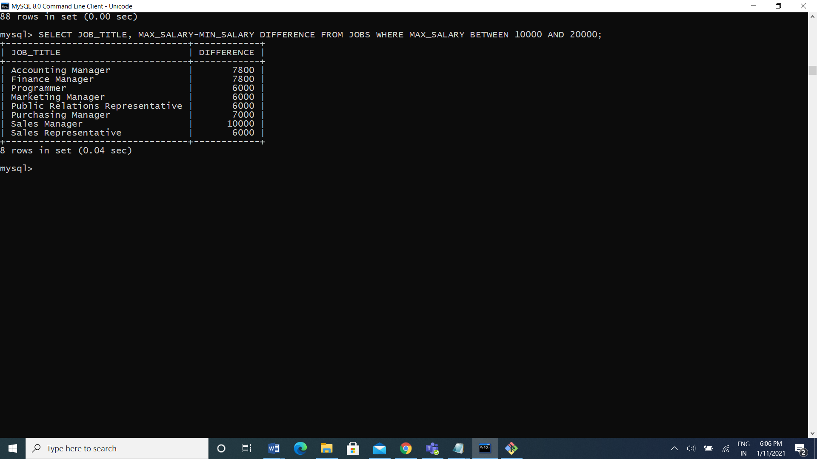

6) Display employees where the first name or last name starts with S.

Ans: select first_name, last_name from employees where first_name like ‘s%’ or last_name like ‘s%’ 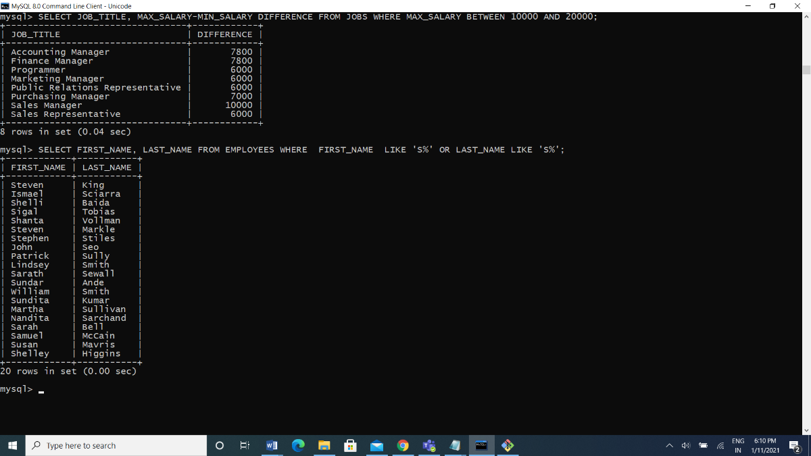

7) Display details of jobs in the descending order of the title.

Ans: select * from job order by job_title;

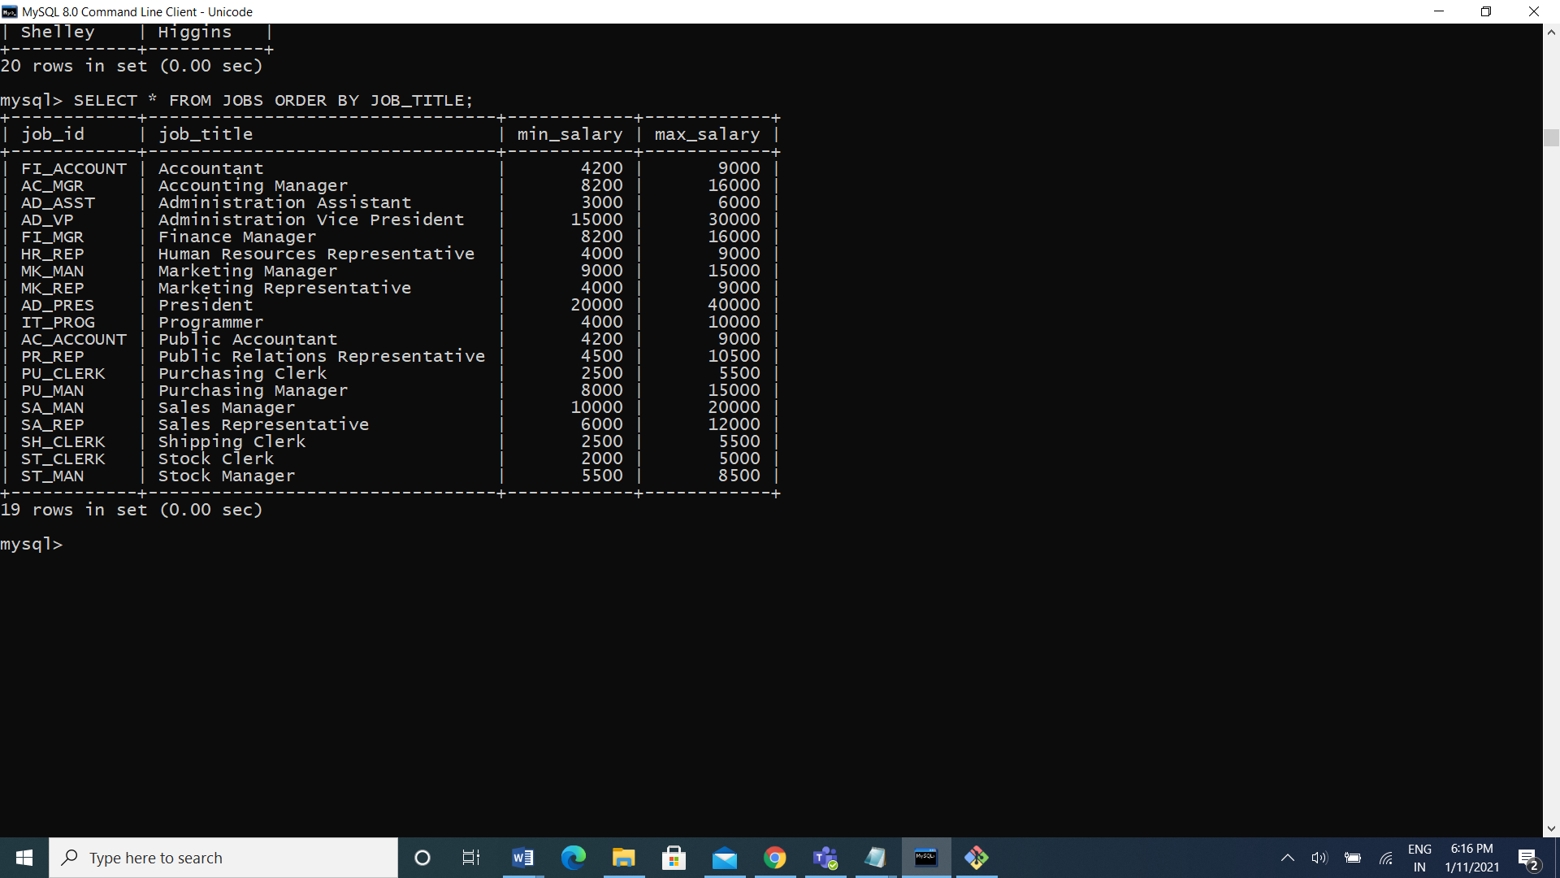

8) Display employees who joined in the month of May.

Ans: select

9) Display details of the employees where commission percentage is null and salary in the range 5000 to 10000 and department is 30.

Ans: SELECT * FROM EMPLOYEES WHERE COMMISSION_PCT IS NULL AND SALARY BETWEEN 5000 AND 10000 AND DEPARTMENT_ID=30; 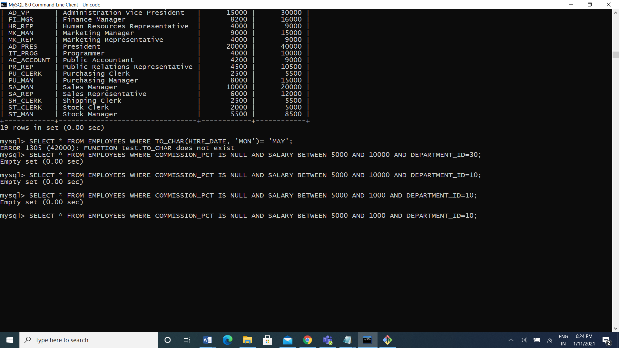

Joints

1). Display job title, employee ID, number of days between ending date and starting date for all jobs in department 30 from job history.

Ans: SELECT EMPLOYEE_ID, JOB_TITLE, END_DATE-START_DATE DAYS

FROM JOB_HISTORY NATURAL JOIN JOBS

WHERE DEPARTMENT_ID=30;

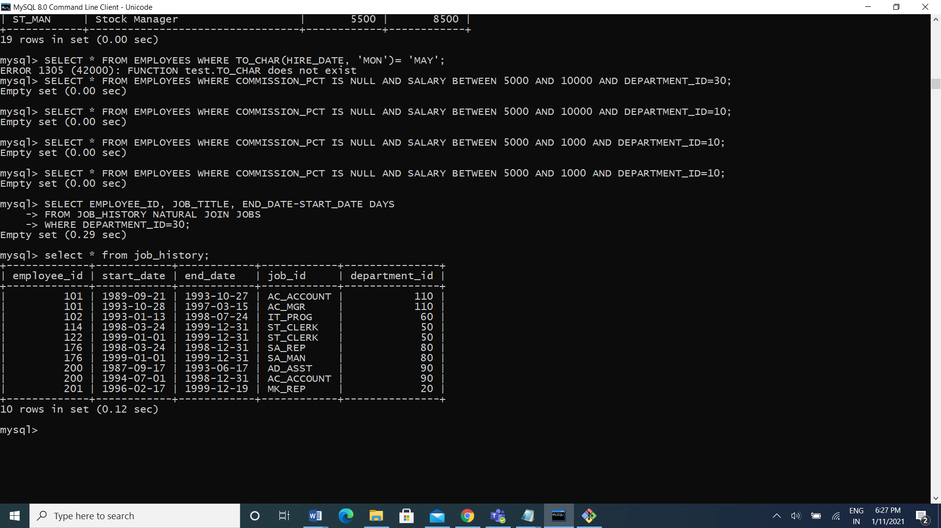

2) Display department name and manager first name.

Ans: select department_name, first_name from departments d join employees e on (d.manager_id=e.employee_id);

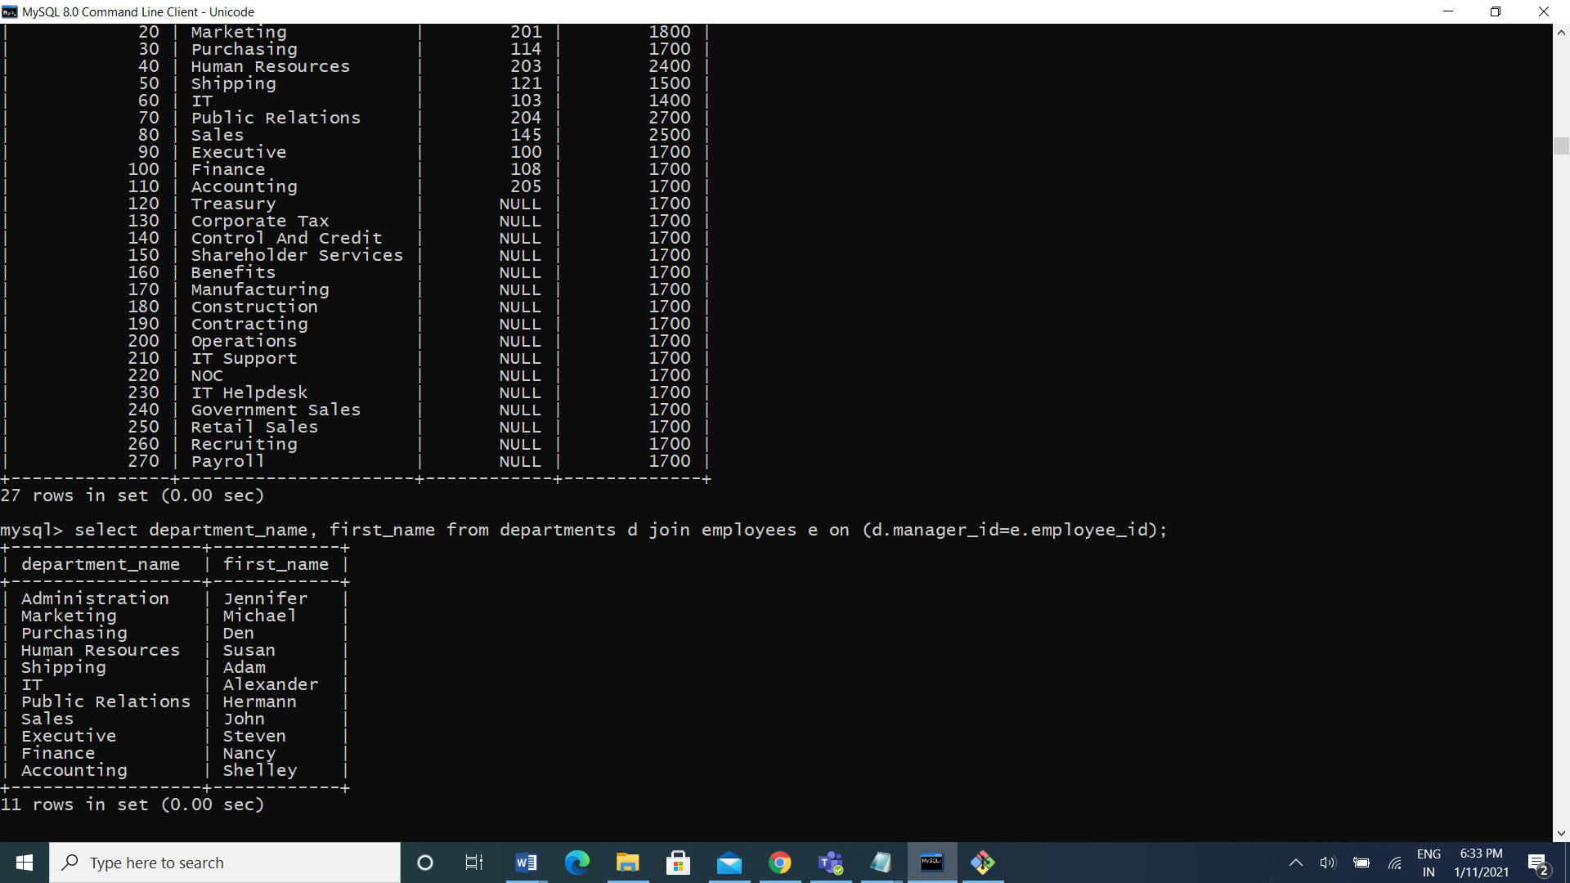

1. Display department name, manager name, and city.

Ans: SELECT DEPARTMENT_NAME, FIRST_NAME, CITY FROM DEPARTMENTS D JOIN EMPLOYEES E ON (D.MANAGER_ID=E.EMPLOYEE_ID) JOIN LOCATIONS L USING (LOCATION_ID);

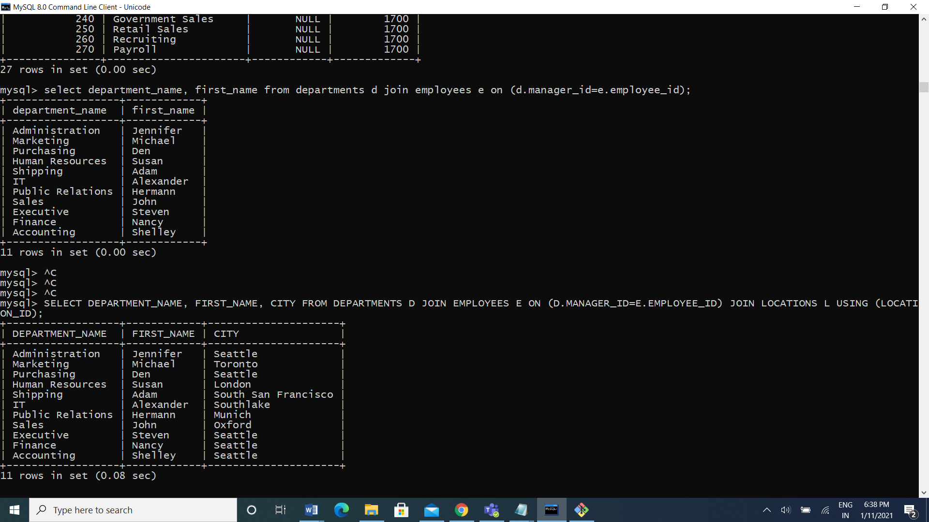

1. Display country name, city, and department name.

Ans: select country_name, city, department_name from countries join location using(country_id) join departments using(location_id);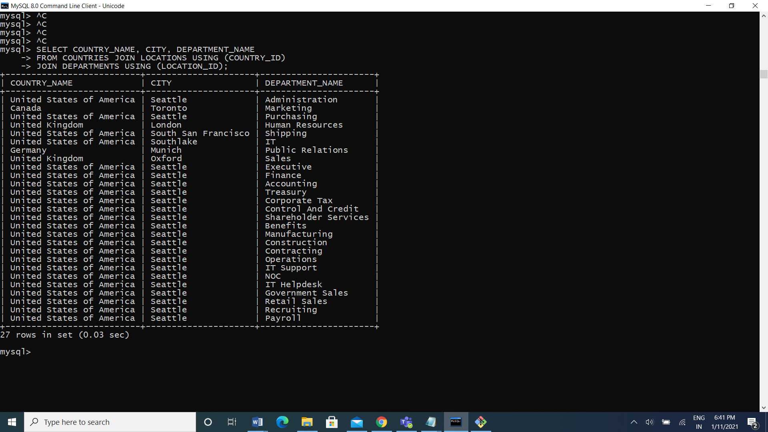

1. Display employee name and country in which he is working.

Ans: select first_name, country_name from employees join departments using(department_id) join locations using(location_id) join countries using(country_id); 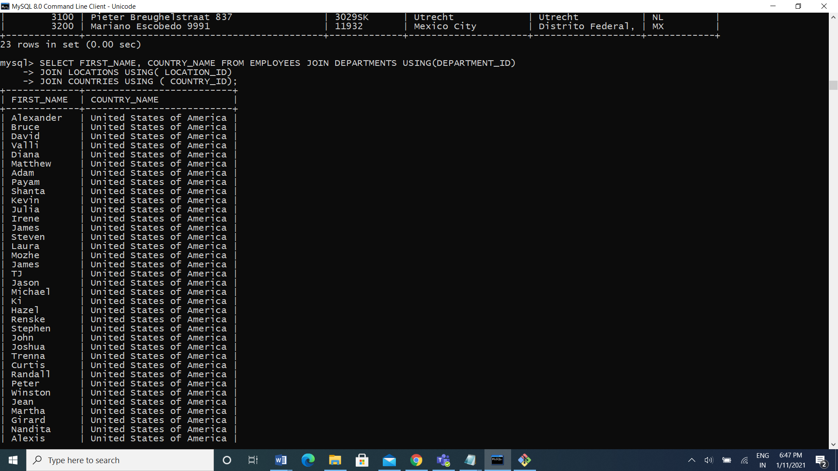

Functions

1. Display employees who joined in the month of May.

Ans: mysql> select first_name,hire_date from employees where hire_date like '%05%';

2. Display first name, salary, and round the salary to thousands.

Ans: select first_name, salary, round(salary, -3) from employees;

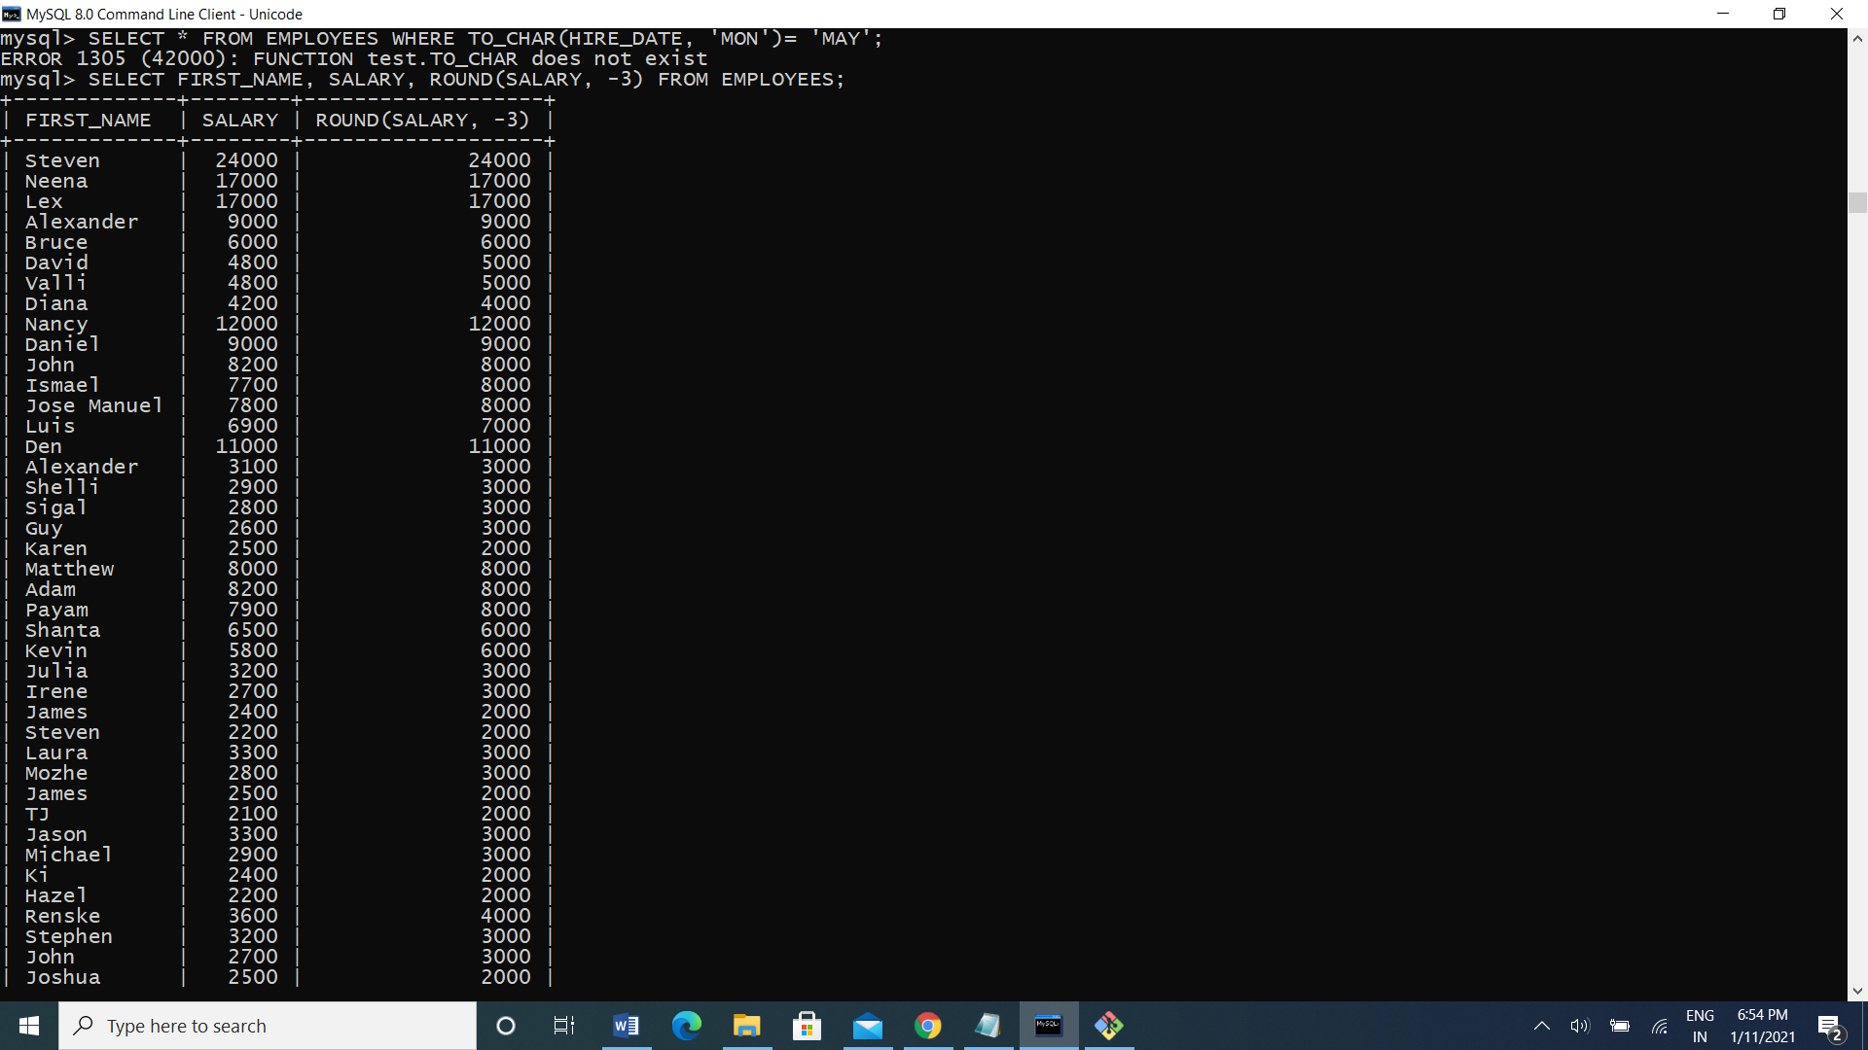

3. Display first name and date of first salary of the employees.

Ans: SELECT FIRST_NAME, HIRE_DATE, LAST_DAY(HIRE_DATE)+1 FROM EMPLOYEES;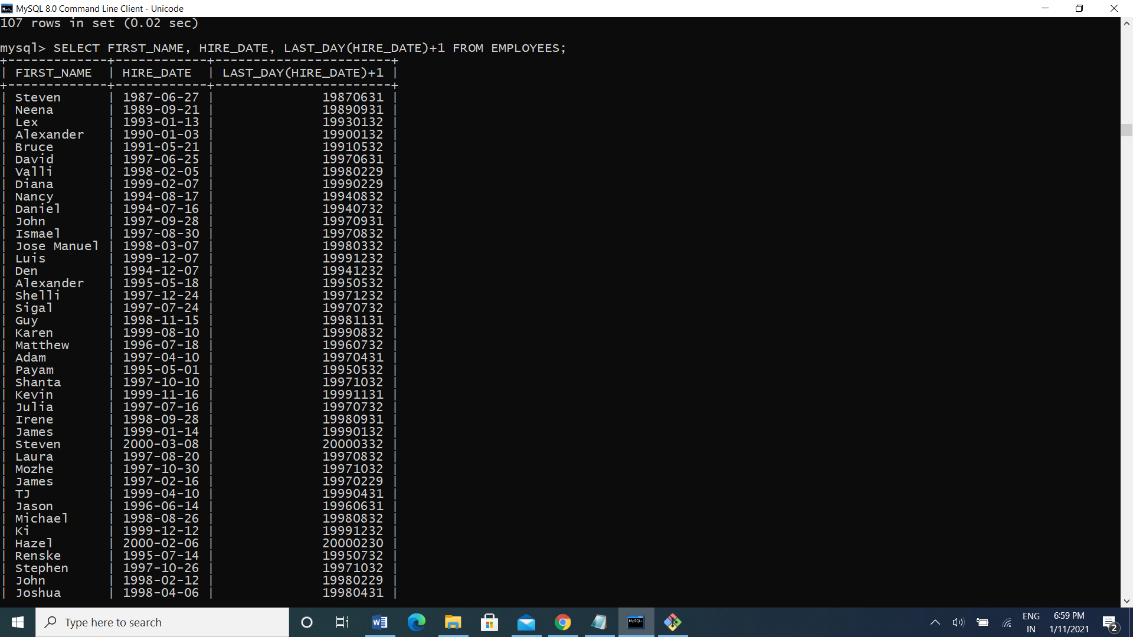

4. Display first name and experience of the employees.

Ans: select first_name, last_name from employees where instr(last_name, ‘B’)>3;

5. Display the length of first name for employees where last name contain character ‘b’ after 3rd position.

Ans: mysql> SELECT FIRST_NAME, LAST_NAME FROM EMPLOYEES WHERE INSTR(LAST_NAME,'B') > 3;

6. Display first name in upper case and email address in lower case for employees where the first name and email address are same irrespective of the case.

Ans: select upper(first_name), lower(email) where upper(first_name)=upper(email);

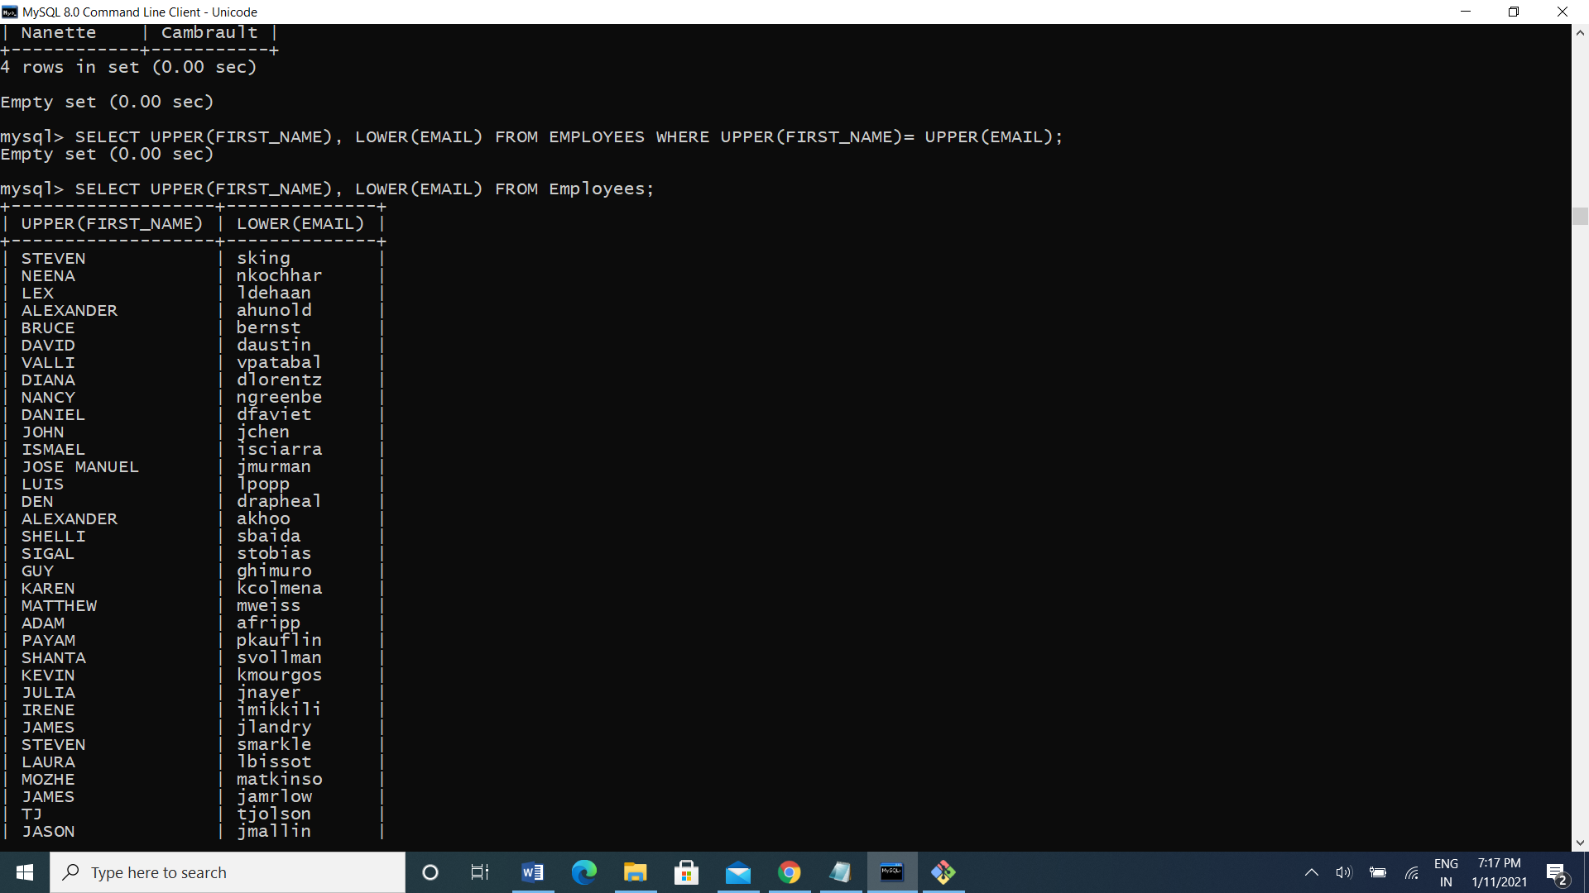

8. Display the number of days between system date and 1st January 1995.

Ans:select sysdate-to_date(’01-jan-1995’)from dual;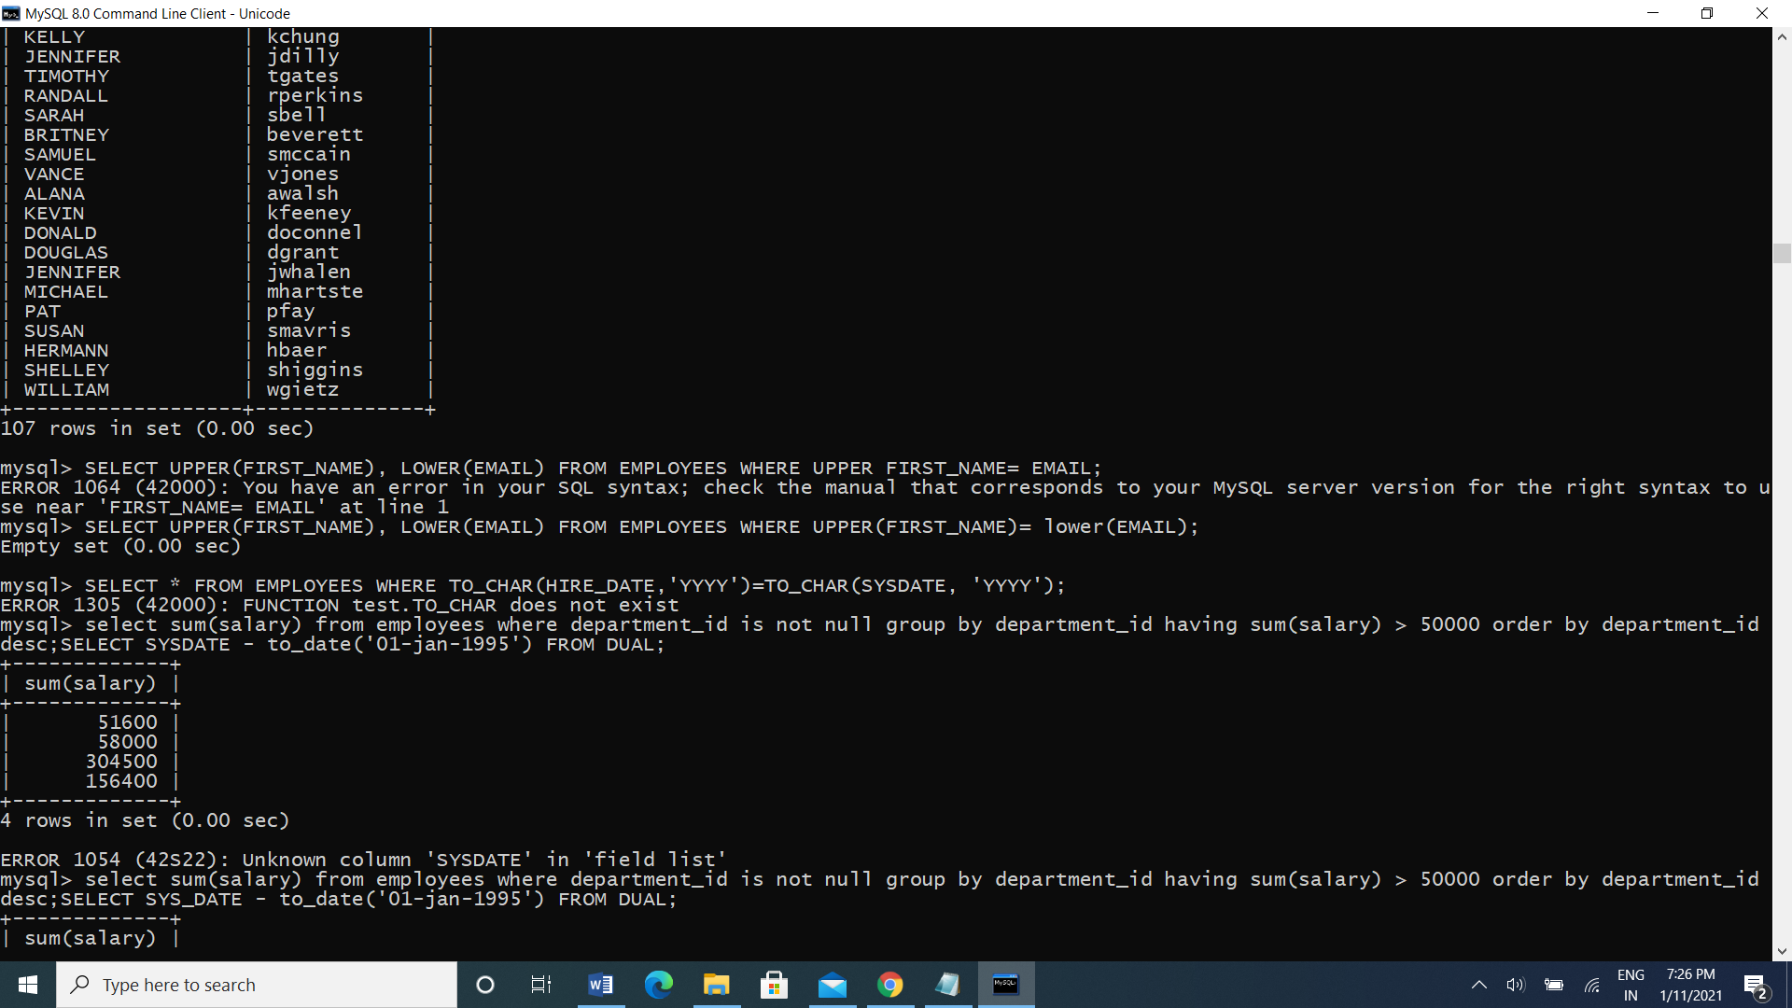

MySQL Aggregate function

1. Display employee ID and the date on which he ended his previous job.

Ans: select employee_id, max(end_date) from job_history f=group by employee_id;

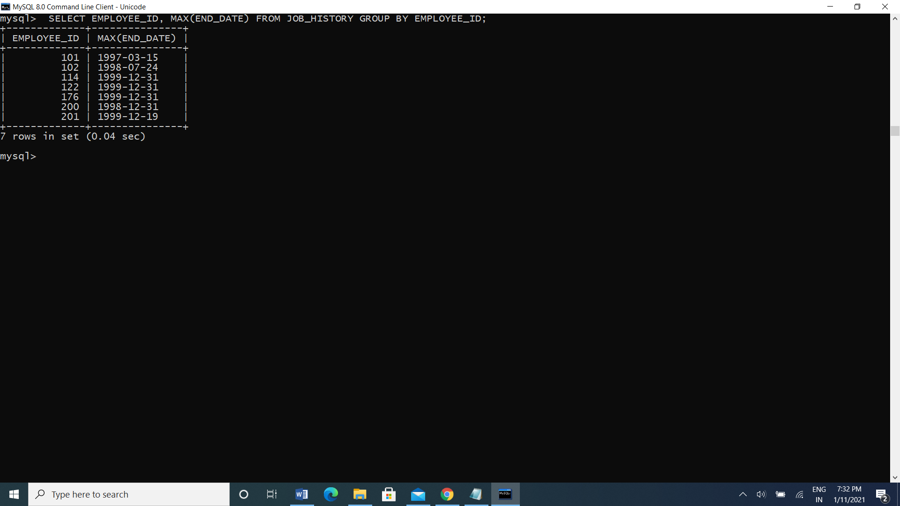

2.Display number of employees joined after 15th of the month.

Ans: mysql> SELECT COUNT(*) FROM EMPLOYEES WHERE HIRE_DATE>15;

select with Group by

1. Display the country ID and number of cities we have in the country.

Ans: SELECT COUNTRY_ID, COUNT(*) FROM LOCATIONS GROUP BY COUNTRY_ID;

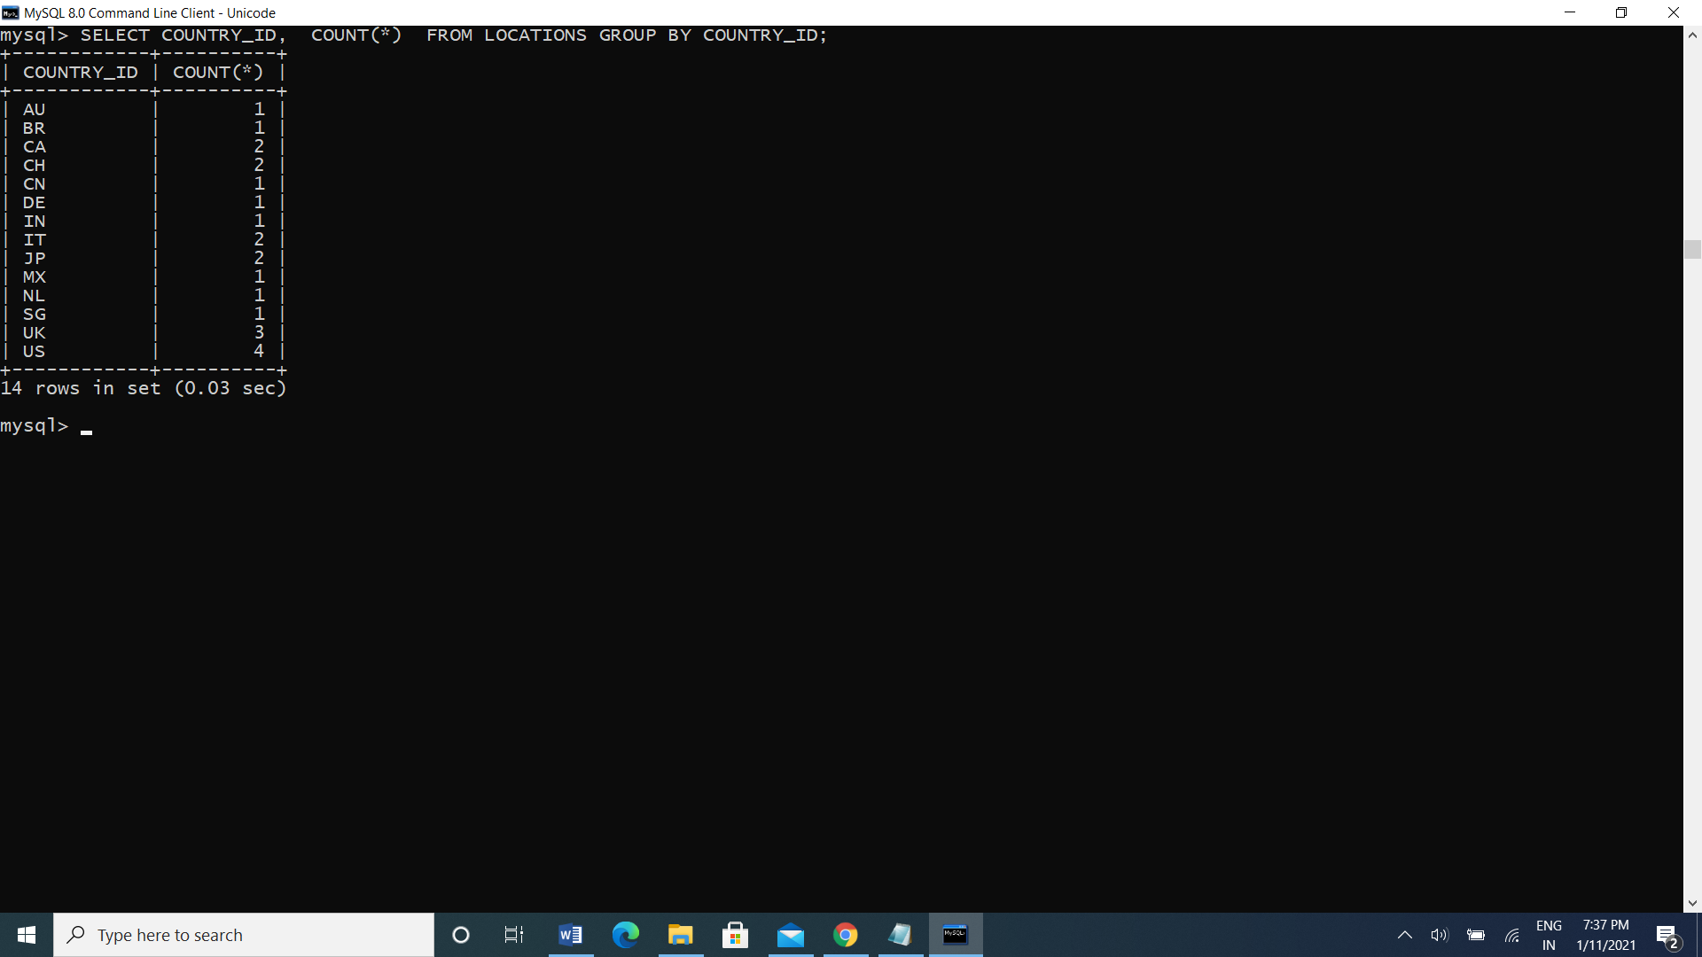

1. Display average salary of employees in each department who have commission percentage.

Ans: SELECT DEPARTMENT_ID, AVG(SALARY) FROM EMPLOYEES WHERE COMMISSION_PCT IS NOT NULL GROUP BY DEPARTMENT_ID

3. Display job ID, number of employees, sum of salary, and difference between highest salary and lowest salary of the employees of the job.

Ans: SELECT JOB_ID,COUNT(*),SUM(SALARY),MAX(SALARY)-MIN(SALARY) SALARY FROM EMPLOYEES GROUP BY JOB_ID;



6. Display job ID for jobs with average salary more than 10000.

Ans: mysql> SELECT JOB_ID,AVG(SALARY) FROM EMPLOYEES GROUP BY JOB_ID HAVING AVG(SALARY)>10000;

8. Display departments in which more than five employees have commission percentage.

Ans: mysql> select department_id from employees where commission_pct is not null group by job_id HAVING COUNT(COMMISSION_PCT)>5;

Day 2 (12-01-2021)

DML Operation:

1. Change salary of employee 115 to 8000 if the existing salary is less than 6000.

Ans: UPDATE EMPLOYEES SET SALARY = 8000 WHERE EMPLOYEE_ID = 115 AND SALARY < 6000;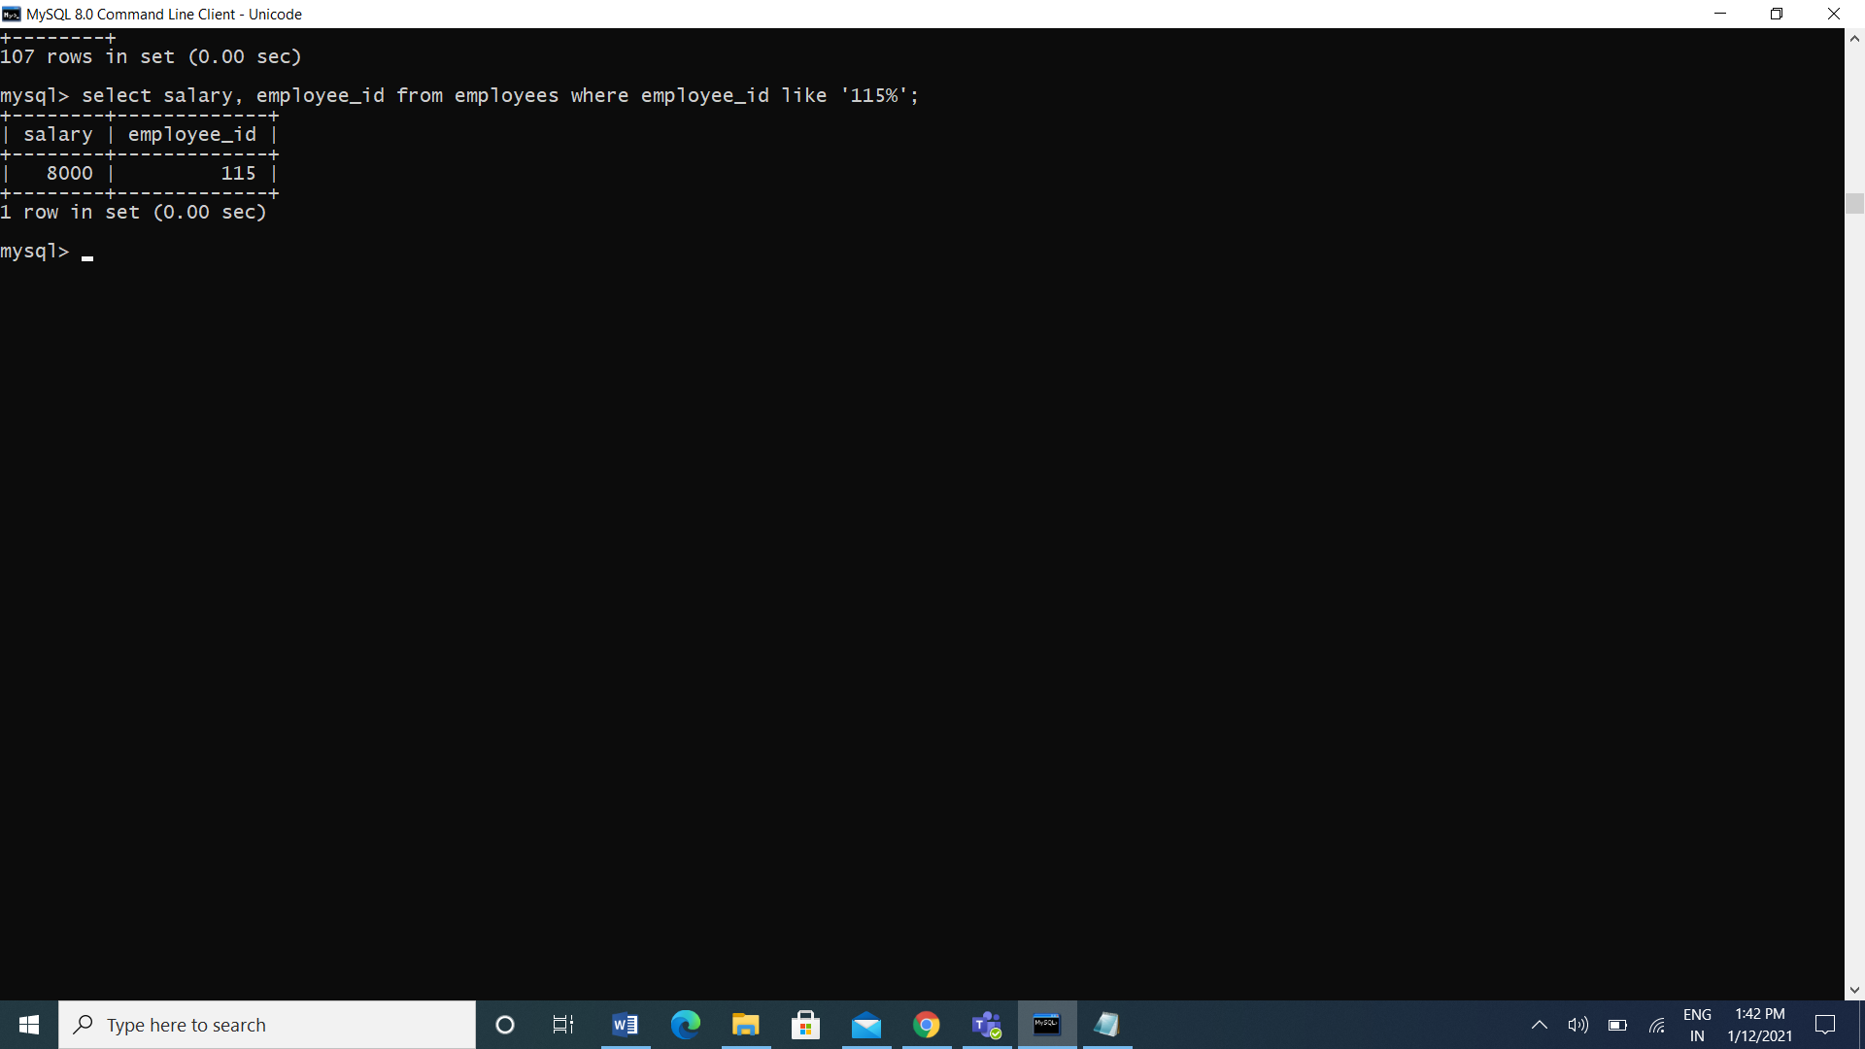

1. Insert a new employee into employees with all the required details.

Ans: insert into employees values(207, 'Madhav', 'Koti', 'madhav', null, SYSDATE(),'AC_ACCOUNT', 25000, null, 115, 120);



1. Delete department 20.

Ans: DELETE FROM DEPARTMENTS WHERE DEPARTMENT_ID like 20;

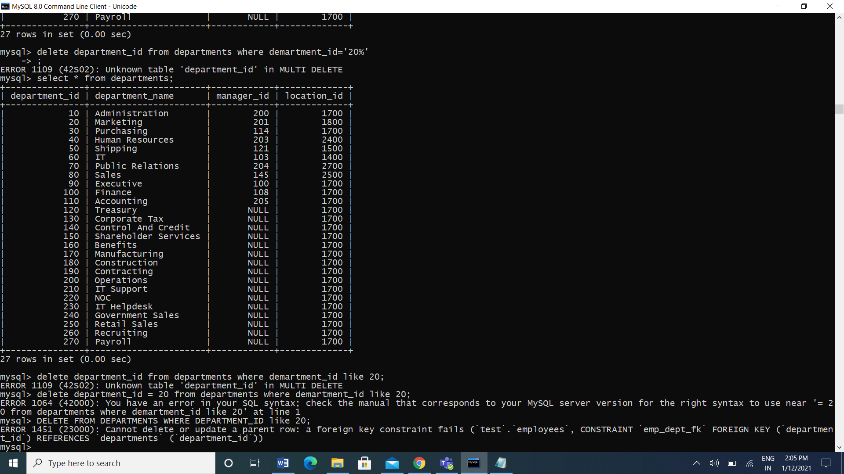

1. Change job ID of employee 110 to IT_PROG if the employee belongs to department 10 and the existing job ID does not start with IT.

Ans: UPDATE EMPLOYEES SET JOB_ID= 'IT_PROG'

-> WHERE EMPLOYEE_ID=110 AND DEPARTMENT_ID=10 AND NOT JOB_ID LIKE 'IT%' ;

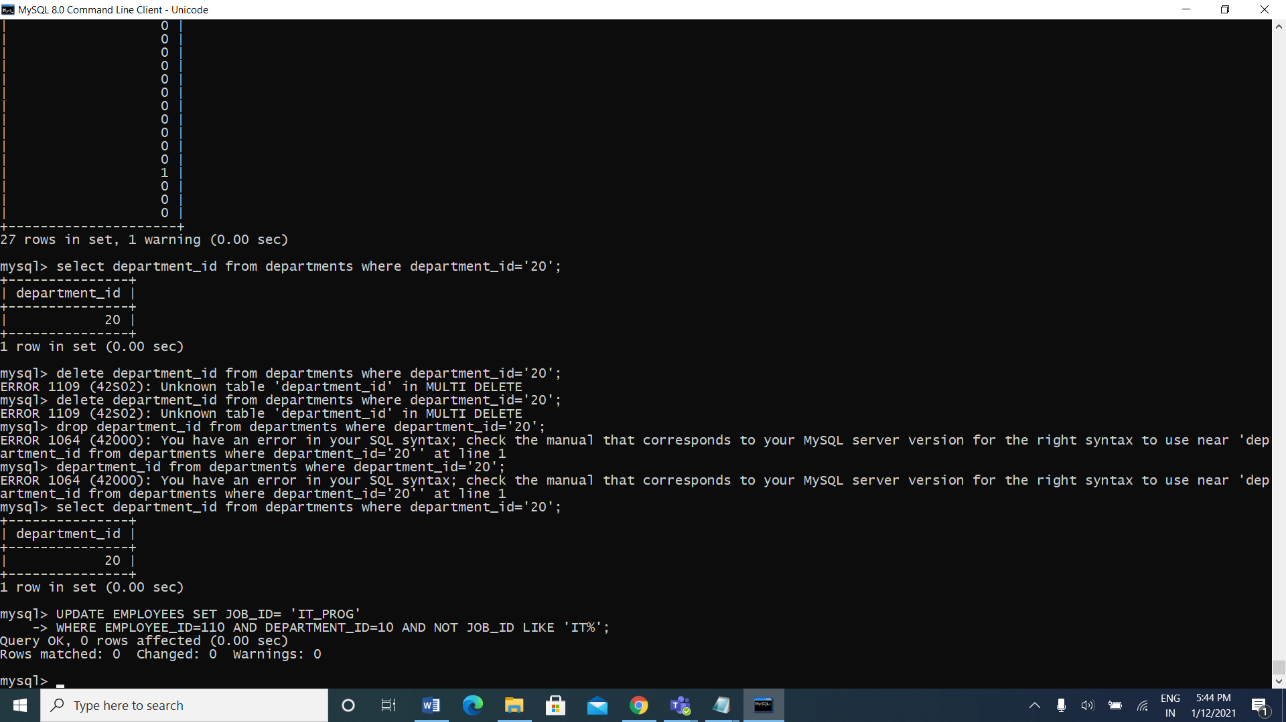

5. Insert a row into departments table with manager ID 120 and location ID in any location ID for city Tokyo.

Ans: INSERT INTO DEPARTMENTS values (152,'HRS',100,1700);

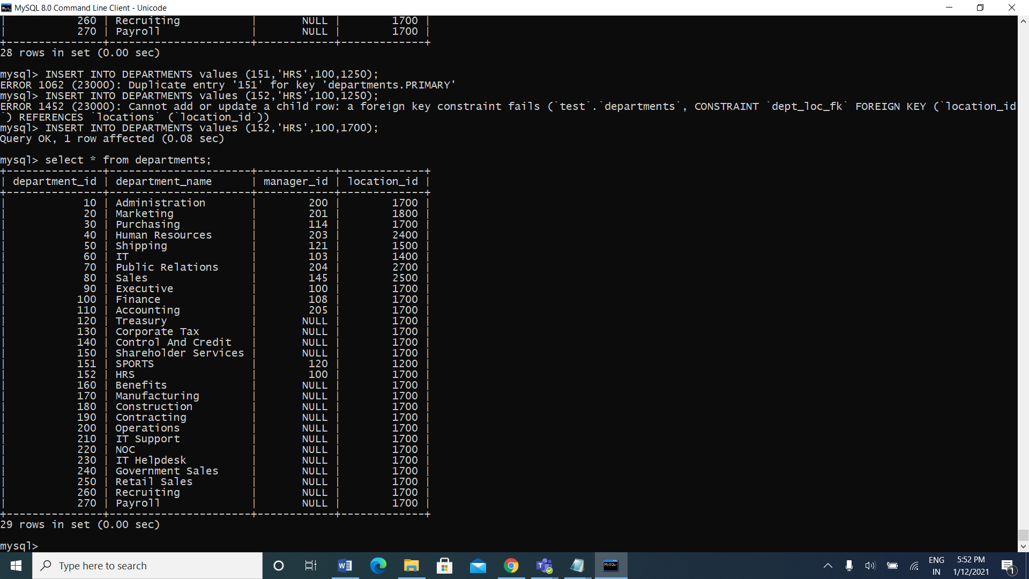

1. Display job title, employee ID, number of days between ending date and starting date for all jobs in department 30 from job history.

Ans: SELECT EMPLOYEE_ID, JOB_TITLE, END_DATE-START_DATE DAYS

-> FROM JOB_HISTORY NATURAL JOIN JOBS

-> WHERE DEPARTMENT_ID=30;

DDL Assignments with Constraints

1. Table ---> Customer

custId, firstName,lastName,age,city, mobileNumber, dob

Add the Constraints

custId is Primary Key

firstName not null

age must be greater than 21

mobile must be unique

Ans: CREATE TABLE customer(custid int primary key, firstname varchar(255) not null, age int, city varchar(20), mobilenumber int unique,dob int, check(age>21));

1. Table ----> Branch

branchId, branchName, city

Add the Constraints

branchId is Primary Key

branchName not null

city not null

Ans: create table branch(branchID varchar(20) primary key, branchName varchar(20) not null, city varchar(20) not null);

1. Table -----> Account

accountNumber, openingBalance, typeOfAccount, status,BankId,CustId

Add the Constraints

accountNumber is primary key

openingBalance must be greater than 5000

typeOfAccount must be saving/current

BankId is foreign key refer to BranchId(Primary key) Branch table

CustId is foreign key refer to Customer(Primary key) Customer table

Ans: create table account(accountnumber int primary key, opening_balance int, typeOfAccount enum('savings','current'), status varchar(10), BankId int, foreign key(BankId)references branch(branchID), CustId int, foreign key(CustId) references customer(custid), check(opening_balance > 5000));

1. Table ----> Transaction

transactionId, transactionDate, MediumOfTransaction, TransactionAmount

Add the Constraints

transactionId is primary key

Ans: create table transaction(transactionid int primary key, transactiondate int, mediumoftransaction enum('online','ofline'), transactionamount int);

5.Table ----> Loan

LoanId, loanAmount, customerId and bankdId

Add the Constraints

loadId is primary key

loanAmount must be +ve

BankId is foreign key refer to BranchId(Primary key) Branch table

Ans: CREATE TABLE loan(custid VARCHAR(6),loan_id varchar (10),bid VARCHAR(6),loan_amount INT(7),CONSTRAINT loan_customer_custid_bid_pk PRIMARY KEY(custid,bid),CONSTRAINT loan_custid_fk FOREIGN KEY(custid) REFERENCES customer(custid),CONSTRAINT loan_bid_fk FOREIGN KEY(bid) REFERENCES branch(bid) );

Sub Query

1. Display details of departments managed by ‘John’.

Ans: SELECT department_name FROM departments WHERE manager_id IN (SELECT employee_id FROM employees WHERE first_name='john');

1. Display employees who did not do any job in the past.

Ans: select * from employees where employee_id not in(select employee_id from job_history);

1. Display job title and average salary for employees who did a job in the past.

Ans: SELECT JOB_TITLE, AVG(SALARY) FROM JOBS, EMPLOYEES WHERE EMPLOYEE_ID IN (SELECT EMPLOYEE_ID FROM JOB_HISTORY);

1. Display country name, city, and number of departments where department has more than 5 employees.

Ans: SELECT COUNTRY_NAME, CITY, COUNT(DEPARTMENT_ID) FROM COUNTRIES JOIN LOCATIONS USING (COUNTRY_ID) JOIN DEPARTMENTS USING (LOCATION_ID) WHERE DEPARTMENT_ID IN (SELECT DEPARTMENT_ID FROM EMPLOYEES GROUP BY DEPARTMENT_ID HAVING COUNT(DEPARTMENT_ID)>5) GROUP BY COUNTRY_NAME, CITY;

1. Display details of manager who manages more than 5 employees.

Ans: SELECT FIRST_NAME FROM EMPLOYEES WHERE EMPLOYEE_ID IN (SELECT MANAGER_ID FROM EMPLOYEES GROUP BY MANAGER_ID HAVING COUNT(*)>5);

6. Display details of current job for employees who worked as IT Programmers in the past.

Ans: mysql> select * from jobs where job_id in(select job_id from employees where employee_id in (select employee_id from job_history where job_id='it_prog'));

7. Display the details of employees drawing the highest salary in the department.

Ans: mysql> select * from employees where salary=(select max(salary) from employees where department_id=department_id);

8. Display third highest salary of all employees

Ans: mysql> select salary from employees e where 2=(select count(distinct salary)from employees where salary >e.salary);

Java Assignments

Day 3 (13-01-2021)

1. do{

Online Examination

1:English , 2 : Math 3 : GK

switch() {

case 1

3 Q

case 2

3 Q

case 3

3 Q

}

Do want to continue ?

}while();

Ans: import java.util.Scanner;

class StudentExam

{

public static void main(String args[])

{

int p=0,q=0,r=0,s=0;

do

{

Scanner sc=new Scanner(System.in);

System.out.println("Enter Exam options");

System.out.println("1.English");

System.out.println("2.Math");

System.out.println("3.GK");

int id=sc.nextInt();

int out1=10;

switch(id)

{

case 1:

if(p==1)

{

System.out.println("Already Attempted");

break;

}

else

{

p=1;

System.out.println("1.Q Hello..........");

System.out.println("1.World 2. Yes 3. No");

Scanner one=new Scanner(System.in);

int a1=one.nextInt();

if(a1==1)

{

s=s+out1;

}

System.out.println("2.Q Hey! My Name is .......");

System.out.println("1.Madhav 2.Raju 3.Ravi");

//Scanner one=new Scanner(System.in);

int a2=one.nextInt();

if(a2==1)

{

s=s+out1;

}

System.out.println("3.Q Janu went to........ tonoght!");

System.out.println("1.Party 2.Nighout 3.Home");

//Scanner one=new Scanner(System.in);

int a3=one.nextInt();

if(a3==1)

{

s=s+out1;

}

}

break;

case 2:

if(q==1)

{

System.out.println("Already Attempted");

break;

}

else

{

q=1;

System.out.println("1.Q Addition of 3+4");

Scanner two=new Scanner(System.in);

int b1=two.nextInt();

if(b1==7)

{

s=s+out1;

}

System.out.println("2.Q Addition of 12+3");

//Scanner two=new Scanner(System.in);

int b2=two.nextInt();

if(b2==15)

{

s=s+out1;

}

System.out.println("3.Q Multiplication of 2*4");

//Scanner two=new Scanner(System.in);

int b3=two.nextInt();

if(b3==8)

{

s=s+out1;

}

}

break;

case 3:

if(r==1)

{

System.out.println("Already Attempted");

break;

}

else

{

r=1;

System.out.println("1.Q Prime Minister of India");

System.out.println("1.Manmohan Singh 2.Soniya Gandhi 3.Narendra Modi");

Scanner three=new Scanner(System.in);

int c1=three.nextInt();

if(c1==3)

{

s=s+out1;

}

System.out.println("2.Q CM of Andhra Pradesh");

System.out.println("1.Chandra Babu 2.Jagam 3.Koti");

//Scanner three=new Scanner(System.in);

int c2=three.nextInt();

if(c2==1)

{

s=s+out1;

}

System.out.println("3.Q Zensar was formed in");

System.out.println("1.1991 2.2000 3.2010");

//Scanner three=new Scanner(System.in);

int c3=three.nextInt();

if(c3==1)

{

s=s+out1;

}

}

break;

}

System.out.println("Do you want to continue y/n?");

Scanner yn=new Scanner(System.in);

char check=yn.next().charAt(0);

if(check=='y')

continue;

else

break;

}

while(p+q+r<3);

if(s>70)

{

s=s+10;

}

System.out.println(s);

}

}

OutPut: 

1. Take n number records through keyboards as Id,Name,Salary,Desg

(array id,name,salary,Desg).

Salary = salary + hra + da – pf;

Hra is 10% salary

Da is 7 % salary

Pf 5 % salary

If desg is manager desg.equals(“Developer”)

15% bonus

If developer 10% bonus

Else

5 % bonus

Id, name, salary( grossSalary +bonus ) and desg.

Ans: import java.util.*;

class EmployeeDetails

{

int n;

public static void main (String[] args)

{

Scanner sc= new Scanner(System.in);

System.out.println("\n Enter total Entries: ");

int n=sc.nextInt();

int id[]=new int[n];

String name[]=new String[n];

double sal[]= new double[n];

String desg[]=new String[n];

for(int i=0;i<n;i++)

{

System.out.println("Enter Id: ");

id[i]=sc.nextInt();

System.out.println("Enter Name: ");

name[i]=sc.next();

System.out.println("Enter Designation: ");

System.out.println("1.Manager 2.Developer 3.Associate");

desg[i]=sc.next();

if(desg[i].equals(1))

{

System.out.println("Hello Manager!");

}

if(desg[i].equals(2))

{

System.out.println("Hello Developer");

}

else{

System.out.println("Hello Associate");

}

System.out.println("\n Enter Salary: ");

sal[i]=sc.nextDouble();

}

for(int i=0;i<n;i++)

sal[i] += 10*sal[i]/100 + 7*sal[i]/100 - 5*sal[i]/100;

for(int i=0;i<n;i++)

{

if(desg[i].equals("Manager"))

sal[i] += sal[i]*15/100;

else if(desg[i].equals("manager"))

sal[i] += sal[i]*15/100;

else if(desg[i].equals("Developer"))

sal[i] += sal[i]*10/100;

else if(desg[i].equals("developer"))

sal[i] += sal[i]*10/100;

else

sal[i] += sal[i]*5/100;

}

System.out.println("Total Number of Employees:"+n);

System.out.println(" *****Employee Details*****");

for(int i=0;i<n;i++)

{

System.out.println("Employee ID:"+id[i]);

System.out.println("Name:"+name[i]);

System.out.println("Salary:"+sal[i]);

System.out.println("Designation:"+desg[i]);

System.out.println("++++++++++++++++++++++++++++++++");

}

}

}

OutPut: 

1. Create EmployeeDetails class with 4 instance array variables.

EmployeeDetails() : memory size for array id,name,salary, desg must assign in constructor at run time.

read()

read all employee id,name,salary,desg

calSalary()

hra, da, pf local variables.

calculate salary

bonus()

apply bonus

display()

display details

EmployeeTest :

Main methods

Object creation

And calling all methods

Take n number records through keyboards as Id,Name,Salary,Desg

(array id,name,salary,Desg).

Salary = salary + hra + da – pf;

Hra is 10% salary

Da is 7 % salary

Pf 5 % salary

If desg is manager

15% bonus

If developer 10% bonus

Else

5 % bonus

Id, name, salary( grossSalary +bonus ) and desg

Ans: import java.util.Scanner;

class EmployeeDetails

{

Scanner sc=new Scanner(System.in);

int n;

EmployeeDetails(int size)

{

n=size;

id=new int [size];

name=new String [size];

salary=new float [size];

salarycpy=new float[size];

desg=new String [size];

}

int []id;

String []name;

float []salary;

float []salarycpy;

String []desg;

void read()

{

for(int i=0;i<n;i++)

{

System.out.println("Enter id ");

id[i]=sc.nextInt();

sc.nextLine();

System.out.println("Enter name ");

name[i]=sc.nextLine();

System.out.println("Enter salary ");

salary[i]=sc.nextFloat();

salarycpy[i]=salary[i];

sc.nextLine();

System.out.println("Enter designation ");

desg[i]=sc.nextLine();

System.out.println("\n");

}

}

void calsalary()

{

for(int k=0;k<n;k++)

{

float hra,da,pf;

hra=salary[k]*0.1f;

da=salary[k]*0.07f;

pf=salary[k]*0.05f;

salary[k]=salary[k]+hra+da-pf;

}

}

void bonus()

{

for(int k=0;k<n;k++)

{

salary[k]=salarycpy[k];

float hra,da,pf;

hra=salary[k]*0.1f;

da=salary[k]*0.07f;

pf=salary[k]*0.05f;

if(desg[k].equals("manager"))

{

salary[k]=(salary[k]+hra+da-pf)+(salary[k]*0.15f);

}

else if(desg[k].equals("developer"))

{

salary[k]=(salary[k]+hra+da-pf)+(salary[k]*0.1f);

}

else

{

salary[k]=(salary[k]+hra+da-pf)+(salary[k]*0.05f);

}

}

}

void display()

{

for(int k=0;k<n;k++)

{

System.out.println("Details of Employee:"+(k+1));

System.out.println("id="+id[k]);

System.out.println("Name="+name[k]);

System.out.println("Salary="+salary[k]);

System.out.println("Designation="+desg[k]);

}

}

}

class Employee

{

public static void main(String args[])

{

Scanner sc=new Scanner(System.in);

System.out.println("Enter Number of records you want to store:");

int x=sc.nextInt();

EmployeeDetails empd=new EmployeeDetails(x);

empd.read();

empd.calsalary();

empd.bonus();

empd.display();

}

}

Output:

